Course Code: COM204

Course Name: Networks Student Name: Ibrahim Hamdy Ibrahim

Instructor: Prof. Mahmoud Elmesalawy Student ID:931230009

Assistant: Eng. Adham Ehab

Academic Year: 2024/2025

# Network Design Documentation

Q1: What is the objective of the project?

A1: The objective of the project is to create a modern network for Helwan National University. In this initial phase, the network will not cover all faculties.Instead, it will be designed to connect only **four main buildings**:

1. The Administration Building
2. Faculty of Computer Science and Information Technology
3. Faculty of Medicine
4. Faculty of Engineering

This design aims to establish reliable communication between the buildings using modern technologies such as VLANs, dynamic routing (RIP,EIGRP,OSPF),Static routing, and securing the network for remote access through Telnet.

# Network Design

I created the network topology using Packet Tracer to connect the four buildings together. Here is a visual representation of the project. I also attempted to make the design resemble the actual layout of the university buildings

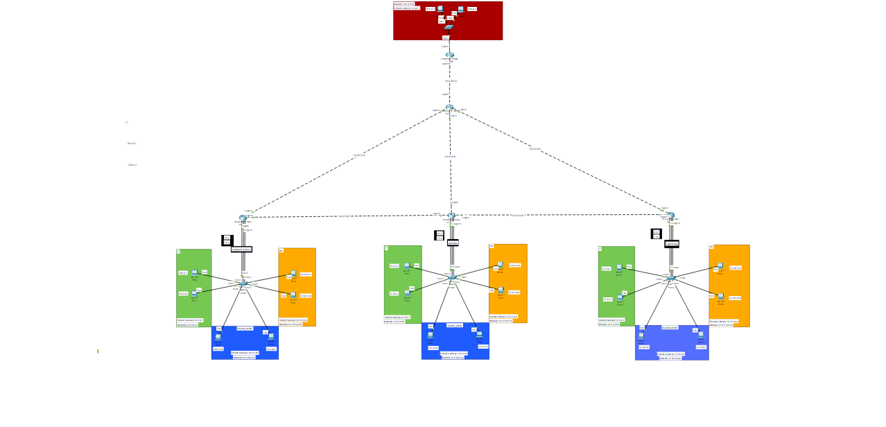

**Components Used:**

* 1. **Routers**:
     + I used **5 routers** of type **Router PT Empty** to connect the four buildings:
       - Faculty of Computer Science and Information Technology
       - Faculty of Medicine
       - Faculty of Engineering
       - Administration Building
       - The Central Building
  2. **Switches**:
     + I deployed **4 switches** of type **2960** to manage internal network communication in each building.
  3. **End Devices**:
     + I added **20 end devices** (PCs) to represent the departments within the faculties (e.g., IT, HR, Student Affairs) in logical networks **(VLANs)** to improve traffic

management within the network.

**Explanation of Network Components**

* **Colors in the image**:
* **Blue: Represents the Student Affairs department**
* **Green: Represents the IT (Information Technology) department.**
* **Orange: Represents the HR (Human Resources) department.**
* **Red: Represents the entire building.**
* **Numbers next to devices**:
  + The numbers like **.1**, **.65**, or **.129G** are shorthand for **IPv4 Addresses**.
  + You can identify the IPv4 Address of a device by:
    1. Accessing the device itself.
    2. Or by checking its external label in the diagram. For example:
       - The HR department is labeled **10.0.0.0**.
       - It contains two devices, **HR1** and **HR2**.

# example:

* + If you select **HR2** from the HR department, its **IPv4 Address** will be **10.0.0.131**.

# VLAN for each department:

* + Each department is assigned a specific **VLAN** to ensure better traffic management, as shown in the image.

# Subnetting Plan

**Table Details:**

* **Building/Department:** Specifies the building or department to which the subnet has been assigned, such as the Human Resources (HR) department or the Information Technology (IT) department within a specific building.
* **VLAN ID:** Represents the unique identifier for the Virtual Local Area Network (VLAN) for each department. VLANs are used to separate departments within a building to improve traffic management within the network.
* **Subnet:** The subnet address assigned to this department (e.g., 10.0.0.0/26).
* **Subnet Mask:** The subnet mask used to define the subnet, such as 255.255.255.192.
* **Host Range:** Indicates the range of IP addresses that can be allocated to devices within the subnet, such as 10.0.0.1 - 10.0.0.62.
* **Broadcast Address:** The broadcast address for the subnet, which is the last address within the subnet (e.g., 10.0.0.63).

**Configuration Details**

**Router Configuration**

**Example Configuration for Computer Science Router:**

Router> enable

Router# configure terminal

Router(config)#hostname Ibrahim_ComputerScience Router(config)# enable password 009

Router(config)# interface gigabitEthernet 0/0

Router(config-if)# ip address 10.0.0.0 255.255.255.192 Router(config-if)# no shutdown

Router(config)# interface gigabitEthernet 0/4

Router(config-if)# ip address 12.0.0.0 255.255.255.0 Router(config-if)# no shutdown

# These are all examples because, to be honest, I'm not quite sure what I should write!!

**Testing**

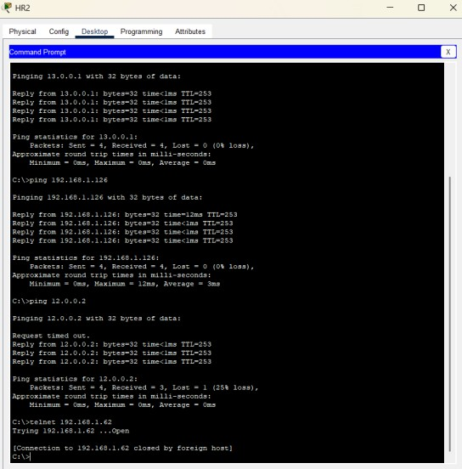ping 13.0.0.1

ping 19.0.0.1

ping 12.0.0.2

telnet 192.168.1.62

# Challenges and Solutions

**Challenges:**

1. Misconfigured VLANs causing communication failure.
2. Routing misconfigurations leading to lack of connectivity between buildings.
3. Addressing IP conflicts during manual setup.

# Solutions:

1. Double-check VLAN IDs and port assignments.
2. Test and validate routing protocols (e.g., RIP, OSPF).
3. Use DHCP where possible to avoid manual IP conflicts.

# Conclusion

This network design successfully connects the four main buildings of Helwan National University with proper segmentation using VLANs and VLSM for IP efficiency. Testing confirmed reliable inter-building communication and secure remote access. This design can be expanded in the future to incorporate additional faculties and services.